**Lumbal Disc Herniation**

Keywords: Back pain, Disc herniation, Hernia, Leg pain, Backache

Lumber disc herniation, commonly known as hernia, is a disorder caused by swelling or rupture of the joint capsule. Joint capsules located between the body of vertebrae are essential for mobility and structural integrity.

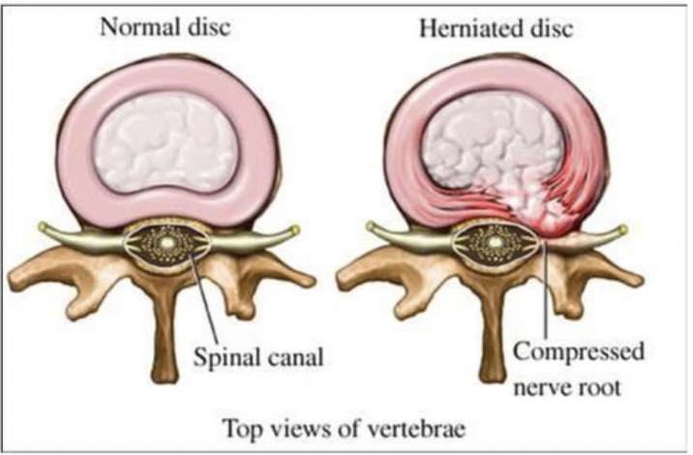Herniation, which is not compressing a nerve, can cause only back pain as a symptom. But if there is nerve compression, it can cause a full or partial loss of function of the nerves.

**Patient Complaints:** Mild to severe back pain, leg or foot pain, leg and foot numbness, loss of strength, urinary or fecal incontinence, and loss of sexual function in male patients can be found.

**Physical Examination Findings:** During the physical examination, paravertebral muscle spasms, pain during the rising of the leg, Positive femoral nerve test, partial or complete numbness of the leg and foot, different ranges of muscle weakness, and decreased reflexes can be found.

**Diagnostics:** Besides the physical examination findings, MRI(Lumber MRI) results should be considered.

**Treatment:** Varies upon the results of the examinations. The first line of treatment is **drug treatment** and rest. In most cases, these management pathways would be beneficial unless there is any proof of nerve compression during the examinations. In these patients, if the pain persists, **physical therapy** should be beneficial. Surgery can be discussed if the patient's pain is not improving and affecting the patient's daily activities.

In the case of compressive nerve evidence, to avoid the risk of nerve damage, **surgery** can be offered.

**Post-Operative Management:** Five hours after surgery, the patient can start walking. Depending on the patient's occupation return to work date can be from 1-2 weeks.